**\*\* SIGHTING ** SIGHTING ** SIGHTING \*\***



**ACTOR PAUL WESLEY SERVES STAR TREK-THEMED COCKTAIL AT RIO HOTEL & CASINO FOLLOWING DAY ONE OF STAR TREK CONVENTION**

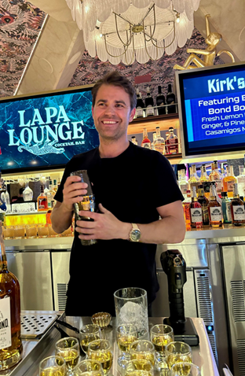

***Images and video can be downloaded*** [***here***](https://spaces.hightail.com/space/T4VsNvMkiX)

**LAS VEGAS (Aug. 2, 2023)** – Going over 40 years strong, “STLV: The 58-Year-Mission”, an annual Star Trek Convention held at [**Rio Hotel & Casino**](https://www.riolasvegas.com/), was a hotspot for celebrity activity on its first day, with over 100 celebrity guests in attendance.

**Paul Wesley**, who plays the role of *Captain Kirk* in the sci-fi series “Star Trek: Strange New Worlds”, took the spotlight at Rio’s newly opened Lapa Lounge on Aug. 1, where he served his exclusive Star Trek-themed cocktail, *Kirk’s Cure-All*. The drink, which showcases Brother’s Bond Bourbon—a brand Wesley co-owns with his “Vampire Diaries” co-star Ian Somerhalder—features a refreshing blend of fresh lemon-lime citrus, ginger, pineapple, and a Casamigos mezcal float.

Follow Rio Hotel & Casino on [Facebook](https://www.facebook.com/RioResort/), [Twitter](https://x.com/RioVegas?ref_src=twsrc%5Egoogle%7Ctwcamp%5Eserp%7Ctwgr%5Eauthor) and [Instagram](https://www.instagram.com/riovegas/?hl=en) for the latest updates.

**About the Rio Hotel & Casino Las Vegas**

Located one block off the famed Las Vegas Strip on Flamingo Road, Rio Hotel & Casino Las Vegas features over 2,500 582 Sq. Ft. all-suite guest rooms, 220,000/sf of convention and meeting space, four newly remodeled pools, and a 150,000/sf casino with 40+ tables and 1000+ slot machines. Dreamscape’s plan for the resort’s future includes a property refresh, from dynamic new dining offerings to a variety of entertainment options. Dreamscape’s intent is to preserve the property’s architecture and honor its legacy. The property will remain open throughout the renovations.

# # #

**Media Contacts**

Alden Tseng | Sandra Esparza

Kirvin Doak Communications

[RioLasVegas@KirvinDoak.com](mailto:RioLasVegas@KirvinDoak.com)