FOR IMMEDIATE RELEASE
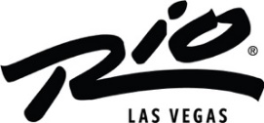
RIO HOTEL & CASINO ILLUMINATES THE LAS VEGAS SKYLINE WITH A DAZZLING DISPLAY OF LIGHTS
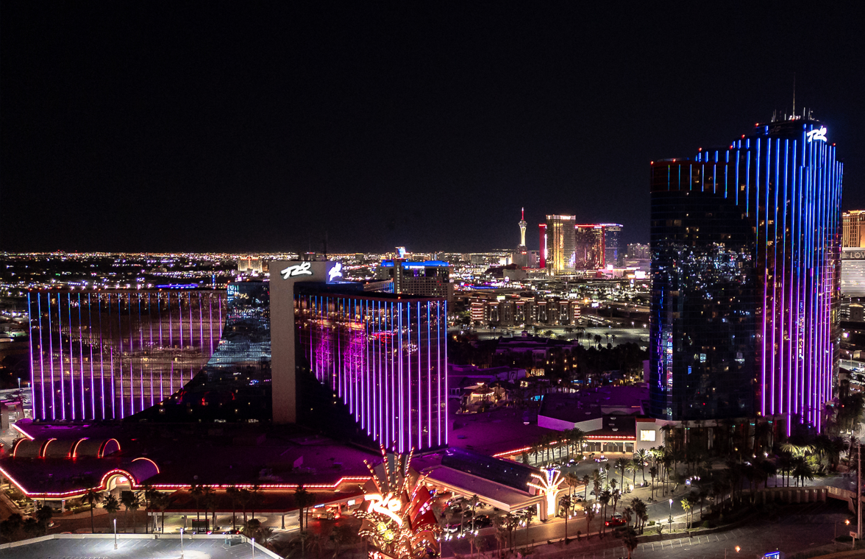
Link to high-res images HERE
LAS VEGAS (March 25, 2024) – Rio Hotel & Casino is lighting up the night sky with a stunning visual art piece enveloping the entire property’s facade. A partnership between legendary lighting designers Chris Kuroda and Andrew Giffin, the expansive installation features over three miles of programmable LEDs to create an ever-evolving light show that can be seen from all over the Las Vegas valley.
One of the lighting business’ most celebrated names, Kuroda is best known for his visual work with renowned jam band Phish spanning over 35 years and almost 1,800 live shows. Straying from the static neon lights and advertisements found along the Las Vegas skyline, the Rio’s exterior will serve as a blank canvas that harnesses Kuroda’s extensive experience within the live music industry to create a dynamic, live art piece where no two shows will ever be the same. Instead of an endless loop of the same colors and effects, Kuroda and Giffin are applying the same methodology used in Phish’s live shows to create a thoughtful, never-before-seen lighting feature where every pixel is meticulously programmed.
“The transformation of the Rio Hotel & Casino has reached a key milestone with the recently renovated exterior.” said Trevor Scherrer, President of Rio. “For decades red and blue neon have been a staple of this iconic property. Led by the creative vision of Chris Kuroda, this new lighting experience is sure to reinforce to both visitors and locals alike that something truly special is happening at the Rio.

For additional information, please visit https://www.riolasvegas.com/.
About the Rio Hotel & Casino Las Vegas
Located one block off the famed Las Vegas Strip on Flamingo Road, Rio Hotel & Casino Las Vegas features over 2,500 580 Sq. Ft. all-suite guest rooms, 220,000/sf of convention and meeting space, a 5-acre pool area, and a 150,000/sf casino with 40+ tables and 1000+ slot machines. Dreamscape’s plan for the resort’s future includes a property refresh, from dynamic new dining offerings to a variety of entertainment options. Dreamscape’s intent is to preserve the property’s architecture and honor its legacy. The property will remain open throughout the renovations.

# # #
Media Contacts
Alden Tseng | Terri Maruca
Kirvin Doak Communications
RioLasVegas@KirvinDoak.com

