FOR IMMEDIATE RELEASE

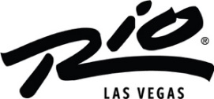

LUCKLEY TAVERN & GRILL SET TO OPEN INSIDE RIO HOTEL & CASINO

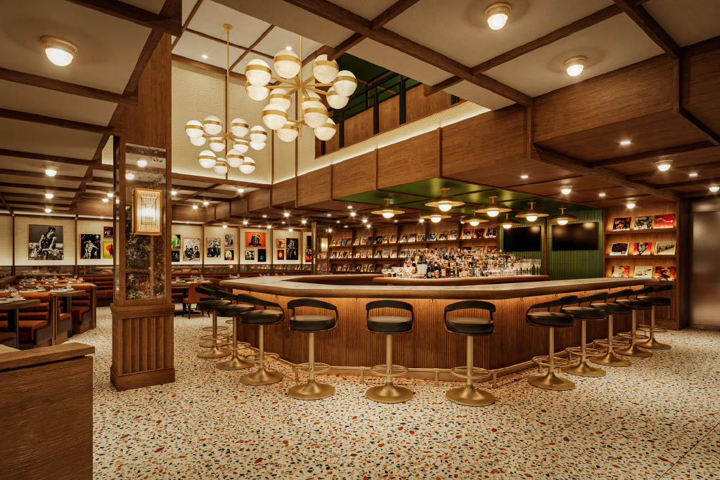
High-res photo can be found here

LAS VEGAS (February 29, 2024) – Rio Hotel & Casino is pleased to announce the arrival of Luckley Tavern & Grill, an enticing new American dining venture by A Perfect Bite, set to debut in late May 2024 within the former All-American Bar & Grill space.

Drawing inspiration from the idyllic Cotswold hills of the English countryside, Luckley Tavern & Grill encapsulates the convivial atmosphere of traditional pubs and the essence of warm hospitality. Reflecting its namesake's welcoming ethos, the restaurant beckons guests to immerse themselves in a culinary adventure filled with hearty flavors and friendly vibes.

Designed to cater to both tourists and locals, Luckley Tavern & Grill will open its doors to the bustling casino floor, offering lunch and dinner services. Anchored by a charming bar featuring an eclectic selection of draft beers, wines, and inventive cocktails, the restaurant invites patrons to enjoy a leisurely meal paired with their beverage of choice.

The menu showcases a playful reinterpretation of American classics, featuring delectable offerings such as lollipop-style buffalo wings, tantalizing Tuna “Pizza,” and innovative Scallops "Benedict." With signature dishes like the Lobster Pot Pie, the impressive 32-ounce Tomahawk steak and a table-side Ice Cream Sundae cart, there's something to satiate every palate.

“We are delighted to announce Luckley Tavern & Grill which will be a key piece to the ongoing renovation of Rio Las Vegas. This exciting new restaurant signifies yet another key milestone in our ongoing efforts to improve the dining options and overall guest experience at the resort.” said Trevor Scherrer, President and CEO of The Rio.

The restaurant is spearheaded by A Perfect Bite's founder and esteemed local restaurateur, Oliver Wharton, whose culinary expertise has left an indelible mark on some of Las Vegas's most iconic dining destinations, including Nobhill, Fix, STACK, and Yellowtail. Assisting him is Chef Alex Resnick, a distinguished graduate of The Culinary Institute of America Hyde Park, whose passion and creativity infuse every dish with culinary finesse.

For additional information, please visit https://www.riolasvegas.com/.

About the Rio Hotel & Casino Las Vegas Located one block off the famed Las Vegas Strip on Flamingo Road, Rio Hotel & Casino Las Vegas features over 2,500 580 Sq. Ft. all-suite guest rooms, 220,000/sf of convention and meeting space, a 5-acre pool area, and a 150,000/sf casino with 40+ tables and 1000+ slot machines. Dreamscape’s plan for the resort’s future includes a property refresh, from dynamic new dining offerings to a variety of entertainment options. Dreamscape’s intent is to preserve the property’s architecture and honor its legacy. The property will remain open throughout the renovations.

# # #
Media Contacts
Kirvin Doak Communications
RioLasVegas@KirvinDoak.com

