FOR IMMEDIATE RELEASE



NOW OPEN: CANTEEN FOOD HALL AT THE RIO HOTEL LAS VEGAS

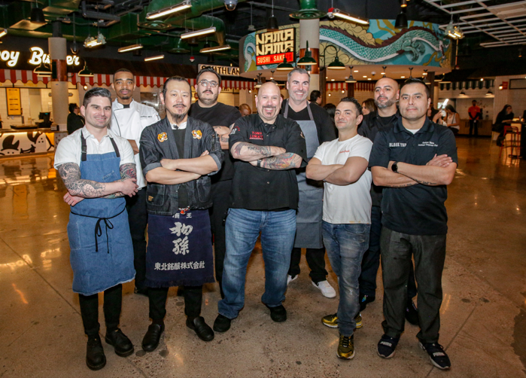
Link to high-res images HERE

LAS VEGAS (January 19, 2023) – Rio Hotel & Casino is thrilled to announce that Canteen Food Hall is now open at the resort. In a newly unveiled dining destination catering to both locals and visitors, an eclectic selection of approachable and boldly distinctive culinary offerings awaits. The lineup features renowned local, national and first-to-market establishments such as Tony Luke's, celebrated for its South Philadelphia cheesesteaks, alongside pioneering concepts like Nama Nama, an original Japanese street food experience. Attaboy Burger, Chef Alex Resnick’s first-to-market burger establishment committed to delivering perfectly executed simplicity, also graces the scene. Ramen enthusiasts can indulge in the creations of Ramen Master Fu at Shogun Ramen. Southland Burrito Co. introduces a groundbreaking Sonoran-style burrito concept by James Beard Award Nominated Chef Marco Herrera, while Tender Crush, an exclusive chicken tender venture by Chris Barish and Julie Mulligan, boasts unique sauces capturing the essence of all five New York City boroughs. This dining destination promises a dynamic and unforgettable culinary experience for all.

“Today signifies a major achievement in the revitalization of Rio Las Vegas.” Announced Trevor Scherrer, the President and CEO of Rio. “We are excited to unveil the inaugural addition to a series of new restaurants and beverage options at this iconic Las Vegas resort. The launch of the Canteen Food Hall reflects the dedication and innovation of our restaurant partners and the Rio team. We eagerly anticipate welcoming both locals and visitors to experience these unique offerings.”

For more information, menus and details regarding the Canteen Food Hall please visit https://www.riolasvegas.com/canteen-food-hall-2

About the Rio Hotel & Casino Las Vegas
Located one block off the famed Las Vegas Strip on Flamingo Road, Rio Hotel & Casino Las Vegas features over 2,500 580 Sq. Ft. all-suite guest rooms, 220,000/sf of convention and meeting space, a 5-acre pool area, and a 150,000/sf casino with 40+ tables and 1000+ slot machines. Dreamscape’s plan for the resort’s future includes a property refresh, from dynamic new dining offerings to a variety of entertainment options. Dreamscape’s intent is to preserve the property’s architecture and honor its legacy. The property will remain open throughout the renovations.
# # #
Media Contacts
Alden Tseng | Terri Maruca
Kirvin Doak Communications
RioLasVegas@KirvinDoak.com

